Impact of Parent-Teacher Communication on Student Behavior in the Classroom
Edward L. Barlow
University of Central Missouri

Author Note
Edward Barlow is a graduate student at the University of Central Missouri in the Communication department. He has several years’ experience in both communication and education. Special acknowledgement to Dr. Hillary Pennell for advising on the method and direction to take the research and Dr. Scott Ragsdale for assisting in finding applicable participants for this study. To contact Edward Barlow please email to exb85100@ucmo.edu.

Abstract
Within the education field, methods to respond to poor student behavior differ from one class to another. Instead of approaching discipline reactively, this study seeks to understand one possible and practical proactive method; does an increase in beneficial communication between parents and teachers help impact student behavior in the classroom? Three groups of participants were surveyed; parents, teachers and administration. This study seeks to both answer this question and offer possible solutions. It is intended that this work should help influence school districts modus operandi in communicating with parents, set systems in place if there are none, and help create artifacts if needed.

Keywords: Communication, educational process, Parent-teacher communication, student behavior

Impact of Parent-Teacher Communication on Student Behavior in the Classroom

Introduction
Educating students in 5th and 6th grade brings many teachers great fulfillment. This age range can also be fraught with long hours and difficult behavior problems. Methods to deter poor student behavior often focus on reactive methods rather than proactive. Creating a positive environment for academic achievement is an important goal but many teachers are finding that they cannot curb behavior problems alone. Adding to this, many teachers often find themselves lacking time and energy to respond to behavior problems in the moment as well as after the day is finished. This situation can sometimes lead to a breakdown in classroom management and, in several circumstances, lead to a breakdown in the relationship of the teacher and student and/or the teacher and parent.
Ultimately, it may be more favorable for both the teacher and parent to work together to offer each student the best possible opportunity to receive an education. The question posed is ‘does communication between teachers and parents help positively impact student behavior?’ Surely not every instance of improved communication would lead to positive student behavior. However, the goal would be to discover if a positive trend could be found. The question posed comes from 7 years in education. Meaningful and effective communication is often cited as the element most lacking between administration and teachers as well as teachers and parents. This research project would focus only on communication between teachers and parents and the role that would play in assisting in positive student behavior. Administration was surveyed, but only as how they perceive the research question to be true or untrue. Their involvement helped provide a third party perspective to triangulate the data as well as in authoritative perspective as they are the individuals who are most likely to assist in student behaviors and parent-teacher mediation.

Literature Review
Mautone, Marcelle, Tresco, & Power (2014) gathered previous studies on parent-teacher relationships and created a new study for parents with ADHD children. The study focused on both academic and behavioral improvements. Areas covered included homework completion, parent-teacher relationship, parent-teacher involvement, parent as educator, and student-teacher relationship. The study was designed primarily for students with ADHD; however, some points remained valid for all students in the classroom. The emphasis of the study sought to determine how a teacher and parent might work together to assist an ADHD student in their academic pursuits.
The most intriguing finding Mautone et al. cited was the correlation between parent-teacher and teacher-student relationships. While most studies look into the relationship of the parent-teacher for child improvement, Mautone et al. found that the stronger the parent-teacher relationship was, the better the teacher viewed their relationship with that parent’s child. Unfortunately, this study focused mainly on the benefits of parental involvement in the household. Although this does not directly relate to the research question at hand, it did provide an interesting look at the potential impact a parent and teacher might have in assisting a child both academically and behaviorally since an improved perception of the student should assist the teacher in maintaining a beneficial relationship with that student.
This study found that there was an increase in academic achievement with classroom behavior included under the umbrella of ‘academic achievement’. With the target student body of this study being individuals diagnosed as ADHD, a certain level of behavior issues would be understood since these individuals are often diagnosed based on behavior. However, the research aimed specifically at academia. This left a gap in research for the specific inquiry towards a possible relationship between student behavior across all personality types and parent-teacher communication.
Thompson, Mazer, & Grady studied computer-mediated communication (CMC) between parents and teachers. In the increasingly digital and smartphone driven world, how parents and teachers communicate continues to evolve. They sought to find what methods were being used and what strengths and weaknesses each avenue possessed. Overall, the study found that an increase in smartphone communication was beneficial. However, many parents and teachers sought to find ways to continue face-to-face communication so that important unspoken cues, mostly body language, were not lost. The use of email between both parties has increased, as has the use of texts, however the need to continue seeing each other was relevant for a mutually beneficial engagement. For this purpose, Thompson, Mazer, & Grady found that Facetime and Skype satisfactorily replaced frequent meetings as each party was privy to body language. Most intriguingly, social media was the avenue with the most potential positive and negative impact on student involvement in the classroom. They noted that a teacher's positive self-disclosure on Facebook influenced student motivation and plays a key role in academic support.
This would lead to behavior change as a secondary cause. First, the student, and most likely the parent, might become more endeared towards the teacher as they are now seen as a ‘real person’ with flaws, pet peeves and passions. Because of that, student behavior is more likely to change because the teacher is cared for in the student’s home. This conclusion certainly has limitations, but the findings of this study to lend itself to a belief that self-disclosure can bring behavioral change in both adults and children. Again, this did not specifically research parent-teacher communication, so a gap remained for the study I conducted.
Kraft and Dougherty researched teacher-family communication and its effects on student engagement. This covered three areas; homework completion rates, on-task behavior, and class participation. This helped shape the study as it was able to help determine that parent-teacher (labeled as teacher-family) communication did positively impact on-task behavior. However, the study itself sought to determine how educators could create student motivation. This helped answer my research question as a by-product but not as the primary inquiry.
The authors noted that student involvement, and therefore on-task behavior, was more complex than needing one condition met. They found that teacher reward methods helped maintain on-task behavior throughout the year as most students have higher involvement at the beginning of the year and lose motivation towards the end. Finding a singular control group becomes difficult because each teacher rewards student participation and positive behavior differently, which then impacts future behavior, both positive and negative. Therefore, my ultimate conclusion must include a note that an increase in communication alone is not the fix-all a teacher may be searching for.
The data analysis covered several subsets. Kraft and Dougherty sought to find trends among different age ranges, ethnicities, genders, socioeconomic status, and differing native languages. Therefore the validation of an inquiry towards parent-teacher communication and student behavior is muddied by a lack of focus on the specific topic I am interested in. They defended their inquiry well enough, calculating every set and subset of information to find possible trends and themes, but an independent inquiry into a specific focus of student behavior is still necessary.

Methodology

Qualitative Paradigm
The research methodology was qualitative in nature. Qualitative research involves the study of a problem or finds meaning within a real-life, contemporary context or setting (Cresswell, 2007). To pursue this research qualitatively, I focused on a single unit, in this case a school. My personal paradigm is a rationalist, so the data and conclusions will validate empirical, theoretical and abstract theories of knowledge. Although many individuals will view reality through their own lens, myself included, each of us will still need to measure our reality against what we have experienced is true, what we know ought to be true and against a reasonable a priori deduction of truth. This will hold the conclusion in line with the interview questions and observations and any possible, if necessary, solutions.

Specific Approach
The approach to this qualitative research will be the case study method (Cresswell, 2007). According to Cresswell (pg. 97, 2017), a case study is:
“...a type of design in qualitative research that may be an object of study, as well as a product of the inquiry. Case study research is a qualitative approach in which the investigator explores a real-life, contemporary bounded system (a case) or multiple bounded systems (cases) over time, through detailed, in-depth data collection involving multiple sources of information, and reports a case description and case themes.”

My study best aligns with this approach because I sought to find an answer to an inquiry along with providing a possible solution. I observed the communicative patterns at a local middle school between teachers and parents in the pursuit of finding if such relationships impact, in any way, student behavior. Since this particular project has many potential influences and outcomes, a case study was necessary to combine them all with the hopes of possibly providing a solution if a problem was found. One limitation for the case study may be its need for specificity at the very beginning. Should I study one case or several? The more cases studies the more diluted the information becomes (Cresswell, 2007). This particular study ignored differing cases and provided a survey for anyone in three groups to answer.

Data Collection
Data was primarily collected through an online survey. Three different surveys were created for three groups of individuals; administration, parents, and teachers. The head administrator of the site sent out the survey to all teachers and parents to answer while I was able to request each administrator to fill one out individually. The questions sought to obtain demographic details, personal experience level, previous communicative encounters, and perspective on whether-or-not communication between the two parties ‘should’ help student behavior, and ‘have’ helped student behavior. Sub-set information was encountered but will be ignored for this study's conclusion.

Participants
In total, administrators, 20 parents and 16 teachers filled out the survey. This is 100% of administrators, approximately 50% of certified teachers, and just under 2% of parents. Further research that reaches a greater percentage of possible participants may assist in validating the findings of this case study.

Data Analysis
To process the data obtained in this study, I used thematic analysis. Thematic Analysis is a form of data analysis within qualitative research that seeks to understand ‘what’ was said instead of ‘how’. There were many different and interesting themes found, but all of them strayed too far from the research question. To assist in thematic analysis, many questions in the survey allowed the participants to freely answer in their own words, instead of only being able to respond with ‘yes’ or ‘no’. Many participants used the option to further discuss their perspectives and feelings regarding the research question. This allowed me to process binary responses as well as extra detailed descriptions to help find themes.

Forms of Validation
Three groups were surveyed to triangulate data. This allowed me to find greater validation within my study. Having the two groups within the study was a necessity. Having the third group, administration, allowed me to triangulate the data from a non-biased third party with direct experience with student behavior problems, and parent-teacher communication methods as they are the form of punishment for student behavior and mediators for teachers and parents when the need arises.
Although my personal paradigm is not postmodern, validation will be found from the individual’s perspective, especially in cases where teacher and parent opinions are similar. Data will need to remain internally valid as well as externally valid. This means that it must hold true to the participants as well as a broad range of other environments. It will need a sense of reliability, furthering the need for multiple cases. Finally, some form of objectivity is necessary for there to be any solid solution or theoretic conclusion.

Analysis
The research question was “does communication between teachers and parents help positively impact student behavior?” 5 administrators, 20 parents and 16 teachers responded to a survey inquiry composing of both multiple choice questions and essay response (freedom to respond or add what they wish to the question). The surveys comprised of similar questions, and ranged from 13-17 questions. There was a difference in question totals since some questions that were applicable to teachers or parents, were not applicable to administrators. However, each group was asked if they felt the research question is true, if they have experienced it to be true and provided with an ability to detail any experience of such a reality. 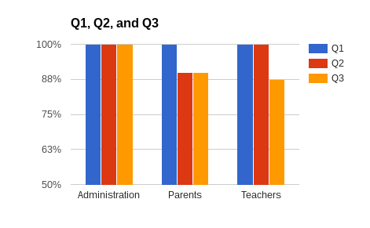
Q1-How meaningful do you feel regular communication with parents are towards beneficial changes in student behavior?
Q2-Has a beneficial communicative relationship between a parent and teacher directly led to a positive behavioral change in a student?
Q3-Looking back, has a meaningful relationship with a parent helped to create a positive response in a student who had regular behavioral issues in the classroom? Feel free to explain.

Questions 2 and 3 are similar, but were spaced out in between other questions regarding types of communication preferred and frequency. The reason this was done was to obtain a reliable conclusion. If there are biases or other hindrances to the truth, a repeated question, especially one that focuses directly on the research question, would hopefully help align us closer to the truth. In this case, we can see that Q2 and Q3, though similar, have different responses. I would argue that this shows that the truth lies somewhere in between these numbers differences. Regardless, the answer remains affirmative. It is worth noting before beginning that each multiple choice had four options, two positive and two negative. They were: ‘very’, ‘somewhat’, ‘not very’, and ‘not at all’. The graph above records only ‘very’ responses. 100% of all responses for all three questions were affirmative. Where the data lacks 100% unity, the difference is between ‘very’ and ‘somewhat’. So even if not total agreement was found, an affirmative response was given 100% of the time to all three questions from each participant. Starting with Q1, “How meaningful do you feel regular communication with parents are towards beneficial changes in student behavior?” 100% of all participants agreed that they ‘felt’ regular communication with parents helps bring beneficial changes in student behavior. This means that those surveyed agree with the researcher’s hypothesis, that parent-teacher communication would do so.
Q2 and Q3 now ask for personal experience. Parents of the student, teachers of the student, and scholastic disciplinarians of the student provided an affirmative response to personal experience regarding parent-teacher communication positively impacting student behavior in the classroom. Q2 received 100% ‘very’ response from both administration and teachers, and 90% ‘very’ from parents. Again, the other 10% gave a ‘somewhat’ response which still qualifies as an affirmative response, but not good enough for the research standards. Q3 received 100% ‘very’ response from administration, 90% ‘very’ response from parents, and 87.5% ‘very’ response from teachers. This change in data between two differently stated questions asking an identical question might be a fluke or have something to do with the last part of the question “who had regular behavior issues in the classroom”. This might have causes a different response from teachers as they now had to think through personal experiences and find if the research questions applied more realistically towards a ‘real’ scenario. The way the question is stated might provoke some participants to remember a specific example and respond based on how that example played out. Regardless, though the data was different, an affirmative response was still given as the rest of both parents and teachers responded with ‘somewhat’ instead of ‘not very’ or ‘not at all’.
Preliminary data supports the research question that a focus on parent-teacher communication could positively impact student behavior in the classroom. To support this, some supplemental data was obtained through free response options (essay format). One theme of partnership emerged between all groups. One parent noted:
“I always try to build a good relationship with my child's teacher. I encourage my kids to build relationships with them as well. They are with them for almost 40 hours a week & need to feel comfortable & confident that they can talk with them about questions & concerns. I want the teacher to feel comfortable contacting me anytime as well.”

To support this, an administrator wrote:
“When a student sees that there is a partnership between the parents and teachers and that all adults are on the same page, it speaks volumes to the student. Additionally, if daily communication occurs and there is follow through both at home and at school, the student will often make positive behavioral gains.”

And another administrator wrote:

“Educators need to communicate with parents more, if we are ever going to truly partner with them.”

Finally a teacher wrote:
“If the parent and teacher have a good relationship, and the student sees that they are not going to get away with things because both parties are working together, it can be a very good experience.”

A theme of unity or partnership, most notably from the parents and administrators, emerged throughout the survey. Teachers most common theme dealt with time and more specifically, not having enough time. To truly fulfill the outcome of positive behavioral change in the classroom, it appears that teachers and parents must corporately view their roles as a partnership. Often times, depending on the parents work hours; the teacher may spend as much time with the child as the parent does, if not more. This further necessitates the view that there is a partnership here in helping the child be a success, not just academically, but socially.
To address the teachers common theme of time, it is worth noting that hypothetically, should student behavior in the classroom improve, more time would be freed to complete parental relationship tasks. This is the difference between proactive and reactive maintenance. Regular maintenance must be kept up with, and a teacher will either pay for it upfront by maintaining a positive relationship with a parent or at the end through dealing with regular behavioral problems. Administration, parents and teachers all agree that the proactive maintenance of communication and relationship building is of great use in classroom management.

Solution
The location that this survey was conducted at had no artifact or system in place for expected communication between teacher and parent. Each teacher was free to contact parents as they wished and does so with a regularity determined by their personal preference. However, in the study I found that administration, parents and teachers all agree that regular communication is necessary in several circumstances.

Frequency
Regarding positive academic topics, parents desired the following frequency:
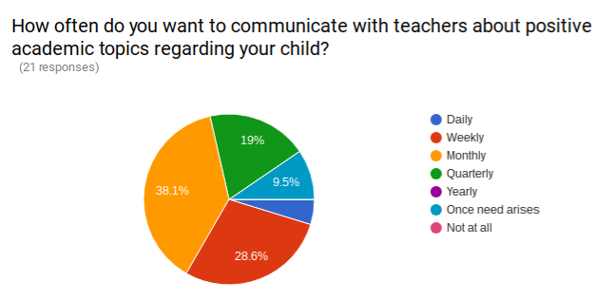
Administration followed with:
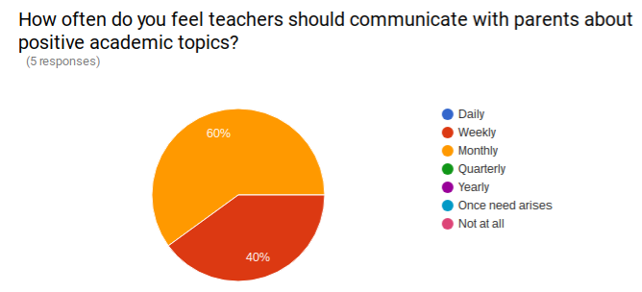

And teachers finished with:
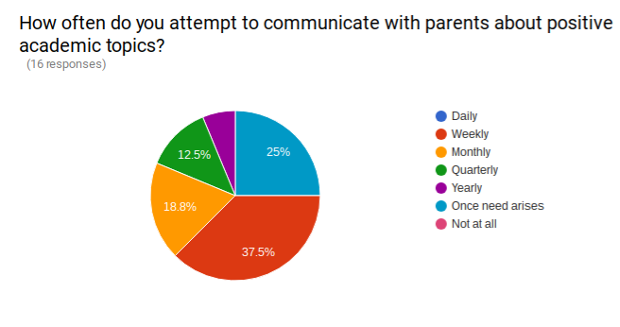
This shows that Administrators and parents desire monthly or weekly positive academic communication, while teachers, who noted a demand for time, mostly chose weekly.
For negative academic topics all groups overwhelmingly chose the ‘once the need arises’ option. This is subjective and will differ from one parent to another. Therefore, regular, possibly weekly updates for parents that include positive and negative reports would suffice as long as the teacher spends more time reinforcing positive comments to the parent.
With regards to positive behavioral topics, the three groups responded accordingly:

Parents
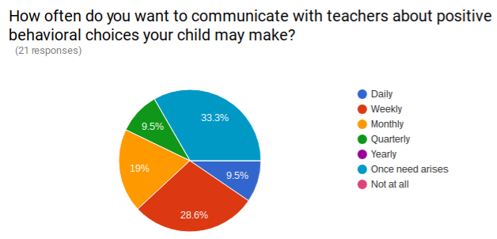
Administration
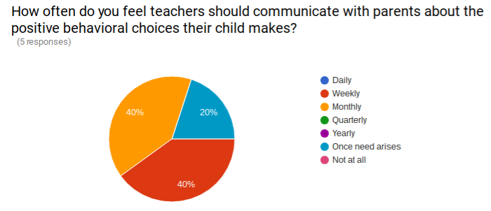

Teachers
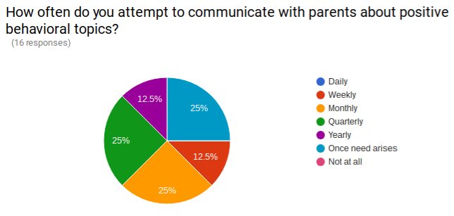
Administration and parents seem to agree that weekly to monthly communication regarding positive behavioral choices is the appropriate target while teachers are split between monthly and ‘once need arises’.
Once again, for negative behavioral choices, all three groups agree that communication should happen ‘once need arises’. This data suggests that the best way to communicate behavioral issues is on a weekly to monthly basis, depending on the student and parent, and communication regarding negative behavioral issues should happen once a situation presents itself.

Form
A question on the survey asked what form of communication provided the best results (subjective). Of the options provided, each group responded accordingly:

Parents
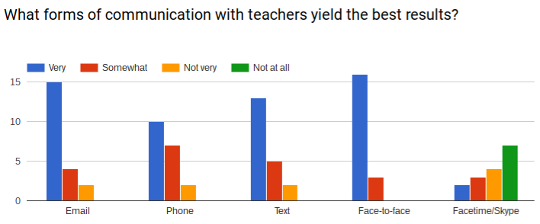
Administration
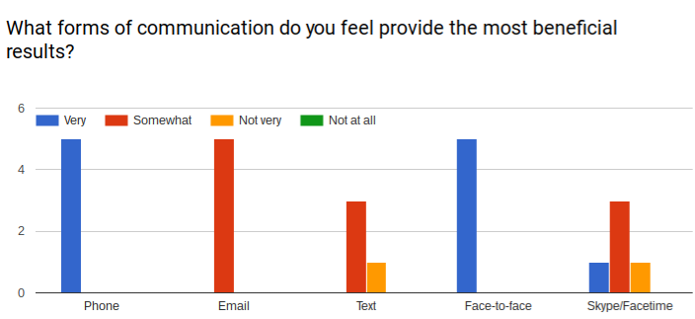

Teachers
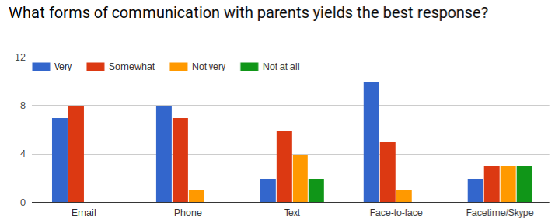

All three groups prefer face-to-face communication between parents and teachers. This is not always obtainable, but must be emphasized. According to previous studies, parents and teachers prefer face-to-face as it provides all the communicative options including body language. If face-to-face is not an option, as will usually be the case, parents prefer email or text/phone, administration prefers phone, and teachers prefer phone and then email.
The data suggests that the first priority of a teacher in communicating with a parent should be face-to-face, next a parent should attempt to call or text a parent and finally the teacher should attempt to email the parent. However, since each parent is different, it is suggested that teachers obtain how individual parents wish to be contacted and fulfill their wishes at the beginning of the year.
Artifacts that point teachers toward these options are highly suggested.

Conclusion
The conclusion of this study is that the individuals in education, as leaders, parents or teachers all agree, experientially, that beneficial parent-teacher communication has and will help to create positive behavioral change in the classroom. Each parent and teacher brings different strengths, weaknesses and perspectives to the relationship so it is difficult to create a cookie cutter solution. However, some criteria should be placed to assist all parties in creating the best possible scenario for students to succeed academically and socially. All data, obtained in multiple choice or free response, pointed towards an affirmative response to the research question. Parent-teacher communication does impact a student’s behavior in the classroom. With this question answered, this case study sought to also help provide solutions to organizations that have difficulty in this area.
Limitations to this study include its simplicity and lack of volume. There lacks a depth of knowledge as to more of the ‘why’s’ and the ‘how’s’ rather than just the ‘what’s’. Knowing why certain relationships breakdown and how to meet those needs would be helpful in future studies. Also, formulating how to best utilize a parent-teacher relationship in positive behavioral response might be beneficial. As it stands, the a priori understanding of this study is that the student will just desire to behave better because they know that their parents and teachers are a united front. This does little to help us understand more complex and intricate nuances in behavioral change needed to fully help conquer classroom management.
Speaking to volume, very little response was obtained for this case study. In the future, the same case study might be done with greater numbers to help the validation of the research findings. Though reliability is probably most certain, further validity would be most beneficial.
I suggest that further research in this area focus on ways teachers and parents can work together to partner in the classroom. This would help show the students a united front instead of only comprehending an ethereal united front only spoken of and never seen. Also it might be of some use to find ways for a school system to communicate with parents instead of individual teachers, and create a standard of communication that parents can adapt to beginning in kindergarten and remain constant through secondary education. This would help them know what to expect with teachers and possibly help unite parents with teachers.
This, it seems, should be our ultimate goal “Working together for our children’s future success”. They are, after all, all of our children. It takes a village to raise a child.

References
Creswell, J. W. (2013). Qualitative inquiry and research design: choosing among five approaches. Los Angeles: SAGE Publications.
Mautone, J. A., Marcelle, E., Tresco, K. E., & Power, T. J. (2014). Assessing The Quality Of Parent-Teacher Relationships For Students With Adhd. Psychology in the Schools, 52(2), 196-207. doi:10.1002/pits.21817
Thompson, B. C., Mazer, J. P., & Grady, E. F. (2015). The Changing Nature of Parent–Teacher Communication: Mode Selection in the Smartphone Era. Communication Education, 64(2), 187-207. doi:10.1080/03634523.2015.1014382
Kraft, M. A., & Dougherty, S. M. (2013). The Effect of Teacher–Family Communication on Student
Engagement: Evidence From a Randomized Field Experiment. Journal of Research on
Educational Effectiveness, 6(3), 199-222. doi:10.1080/19345747.2012.743636

